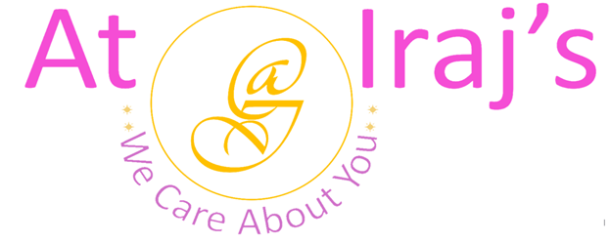
Wellness Royal Kashmiri Kahwa Tea
Ingredients: Assam Green Tea, Saffron, Almonds, Cardamom , Cinnamon, Clove, and Rose Petals.
Product Description: This package contains 100% organic Royal Kashmiri Kahwa Tea.
Benefits:

Green Tea
- Rich in polyphenols which helps to reduce inflammation and fight cancer.
- Contains epigallocatechin-3-gallate (EGCG) also known as catechin which are natural antioxidants helps in preventing cell damage .
- Improves brain functioning.
- Lowers risk of cardiovascular diseases.
- Helps in weight loss, liver disorders, type 2 diabetes, and alzheimer’s.
Saffron
- Stabilizes mood, balances brain hormones which has positive effect on anxiety and depression
- Relieves PMS.
- Reduces blood pressure, cholesterol, and triglyceride levels.
- Memory booster and lowers the risk of neurodegenerative diseases.
- Anthocyanins and carotenoids in saffron neutralize free radicals and reduces the risk of cancer, arthritis, and heart diseases.
- Improves skin conditions like eczema and psoriasis.

Almonds
- Rich in antioxidants, fiber, proteins, and vitamin-E.
- Increases metabolism.
- Maintains blood pressure, cholesterol, and body fat levels.
- Using raw almonds in tea will release flavonoids, phenolic acids, and proanthocyanidins from almond skin helps lower inflammation and helps fight against food borne illness.
- Reduces the risk of cancer, kidney, and heart diseases.
- Manages body weight and enhances bone health.

Cardamom
- Rich in antioxidants, antimicrobial, diuretic (It is a type of drug that helps kidney to get rid of sodium and water from your blood) properties, minerals and vitamins.
- Helps with skin conditions like acne, eczema, psoriasis, inflammation and irriration.
- The high potassium levels act as vasodilator which helps in reducing risk of atherosclerosis, heart attack, and stroke.
- Enhances red blood production which helps in circulating oxygen in the body.
- Improves oral health and digestion issues.
Cinnamon
- Boosts metabolism and brain function.
- Increases cell turnover and fights free radicals causing ageing.
- Lowers blood sugar levels, risks of cancer, alzheimer’s, and parkinson’s diseases.
- Helps in weight loss.
- Subdues helicobacter pylori bacteria which causes peptic ulcers.
- Helps with PMS symptoms.
Clove
- Rich in antioxidants, minerals, and vitamins.
- Reduces risk of chronic diseases.
- Detoxifies and improves functioning of liver.
- Promotes good oral health.
- Regulates hunger levels.
Rose Petals
- Helps with dysmenorrhea and PMS symptoms.
- Reduces stress and anxiety.
- Decreases sebum production, treats scalp issues, and promotes overall healthy hair growth.
- Improves immunity.
- Helps sleep better.
- Lowers risk of chronic diseases.
- Soothes respiratory tract, lung, and throat infections.

- Tea Making Instructions:
Step 1: Boil 7 to 8 oz of water.
Step 2: Add one teaspoon or 3 grams of tea.
Step 3: Steep for 3 minutes.
Step 4: Strain your tea in a cup.
Step 5: Enjoy your wellness royal kashmiri kahwa tea.

Note:
- At Iraj’s we use 100% natural products, the above-mentioned benefits are not totally guaranteed.

For other products related info please visit us at: www.atirajs.com
If you need additional info or have questions related to any of our products, please email us at: support@atirajs.com
Always remember: We Care About You !!

Precaution:
This product (Royal Kashmiri Kahwa Tea) is for external use only. Keep out of reach of children. If you are pregnant, nursing or have any medical condition please consult a doctor before use of this product. If you are allergic to any of the ingredients do not consume. If nausea, vomiting, or diarrhea occurs do not use this product and contact a doctor immediately.

Disclaimer:
The above statements have not been evaluated by the FDA. This product (Royal Kashmiri Kahwa Tea) is not intended to diagnose, treat, cure, or prevent any diseases.

