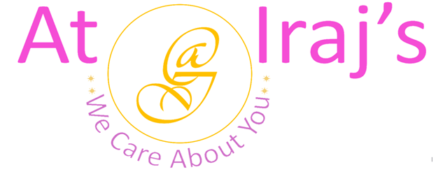
Anti-Bacterial Acne Face Pack
Ingredients: Bentonite Clay also known as Fuller’s Earth, Ocimum Tenuiflorum, and Azadirachta Indica.

Scientific Name | Common Name
Bentonite Clay | Multani Mitti
Ocimum Tenuiflorum | Tulsi
Azadirachta Indica | Neem

Product Description: This package contains 100% organic Anti-Bacterial Acne Face Pack powder.

Benefits:
Multani Mitti
- Cleanses skin deeply by removing dirt and impurities.
- Removes and controls excess oil and sebum.
- Reduces blackheads/whiteheads, acne scars, and blemishes.
- Evens out and brightens skin tone.
- Shrinks the appearance of pores.
- Exfoliates your skin.
Tulsi
- Rich in antimicrobial, anti-bacterial, anti-fungal and anti-inflammatory properties.
- Fights acne and reduces pigmentation.
- Soothes eczema.
- Cleans skin pores and removes excess oil
- Regular use can lighten dark spots
- Prevents early signs of ageing.
- Clears dead skin cell and prevents blackhead and whiteheads.
- Restores skin’s moisture and helps with dryness and flakiness.
- Protects skin from sun exposure and UV radiation.

Neem
- Rich in antioxidants and vitamin E.
- Helps in clearing acne scars, pigmentation, and blackheads.
- Reduces skin inflammation, redness, and irritation.
- Enhances skin tone by increasing skin glow naturally.
- Reduces wrinkles and fine lines.
- Natural skin moisturizer.
- Soothes itching.
- Boots skin’s collagen and elasticity
- Heals minor skin allergies

How to Use:

- Application Instruction:
Step 1: Take 1 tablespoon each of anti-bacterial acne face pack, honey and 1 teaspoon of yogurt and make a thick paste by using rose water
Step 2: Apply it to your face and neck and leave it on for 30 minutes.
Step 3: Wash your face with cool water and pat dry.
Step 4: Apply hydrator or moisturizer.
Note:
- At Iraj’s we use 100% natural products, the above-mentioned benefits are not totally guaranteed.
- Individual results may vary depending on skin type.

For other products related info please visit us at: www.atirajs.com
If you need additional info or have questions related to any of our products, please email us at: support@atirajs.com
Always remember: We Care About You !!
Precaution:
This product (Anti-Bacterial Acne Face Pack Powder) is for external use only. Keep out of reach of children and avoid contact with eyes. Before application do a small strand or patch test behind your ear and wait for 24 hours to make sure you are not allergic or sensitive to this product. If any itching, redness or burning occurs do not use this product and contact a doctor immediately. Not intended for eyebrows or eyelashes. If you are pregnant consult a doctor before application of this product.
Disclaimer:
The above statements have not been evaluated by the FDA. This product (Anti-Bacterial Acne Face Pack Powder) is not intended to diagnose, treat, cure, or prevent any diseases.

