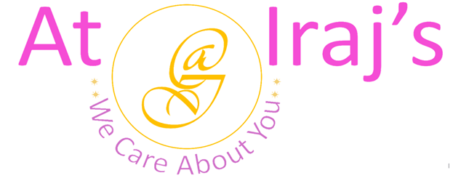
Indigo Powder
Scientific Name: Indigofera Tinctoria.
Product Description: This package contains 100% organic Indigo powder.

Benefits:
- Nourishes and acts as a deep conditioner for your hair.
- It makes your hair stronger, thicker, and radiant.
- Prevents hair loss and corrects hair thinning.
- Treats dry, damaged, and unhealthy hair.
- Restores natural texture and health of the hair.
- Prevents scalp infection and dandruff.
- Promotes faster hair growth
- Prevents premature graying of hair.

How to Use:
Approximate Quantity:
- For short hair (Shoulder length and above)- 75 to 100 grams
- Medium hair (mid-level back and above)- 150 to 200 grams
- Long hair (Waist and above)- 220 to 250 grams

- For Hair Dye:
First Step Henna Treatment
Step 1: Take required amount of henna powder and make paste with warm water.
Step 2: Apply the paste to clean and dry hair using layer method covering scalp, roots, and entire length of your hair.
Step 3: Cover your hair with shower cap and leave it for an hour
Step 4: Rinse your hair without applying hair cleanser or shampoo.
Second Step Indigo Treatment
Step 1: The following day, take required amount of indigo powder and make paste with warm water.
Step 2: Apply the paste to clean and dry hair using layer method covering scalp, roots, and entire length of your hair.
Step 3: Cover your hair with shower cap and leave it for an hour
Step 4: Rinse your hair without applying hair cleanser or shampoo.
Step 5: Wash your hair using At Iraj’s herbal cleanser.

Note:
- At Iraj’s we use 100% natural products, the above-mentioned benefits are not totally guaranteed.
- The amount of Indigo powder depends on length and thickness of hair, the quantities mentioned above are estimated.
- Individual results may vary depending on hair type, existing chemical build up on hair

For other products related info please visit us at: www.atirajs.com
If you need additional info or have questions related to any of our products, please email us at: support@atirajs.com
Always remember: We Care About You !!
Precaution:
This product (Indigo Powder) is for external use only. Keep out of reach of children and avoid contact with eyes. Before application do a small strand or patch test behind your ear and wait for 24 hours to make sure you are not allergic or sensitive to this product. If any itching, redness or burning occurs do not use this product and contact a doctor immediately. Not intended for eyebrows or eyelashes. If you are pregnant consult a doctor before application of this product.

Disclaimer:
The above statements have not been evaluated by the FDA. This product (Indigo Powder) is not intended to diagnose, treat, cure, or prevent any diseases.

