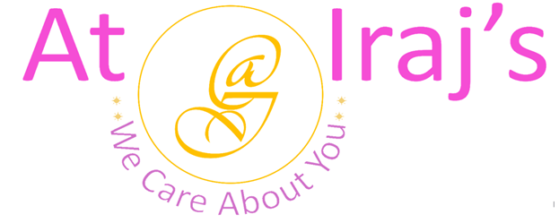
Reetha Powder
Scientific Name: Sapindus Mukorossi.
Product Description: This package contains 100% organic Reetha powder also known as Soapnut.

Benefits:
- Rich in antibacterial and antifungal properties
- Prevents hair fall.
- Natural shampoo and deep cleanses your hair.
- Leaves hair radiant and soft.
- Treats dandruff, frizzy, and split hair.
- Good conditioner for hair.
- Used in Lice treatment.
How to Use:
- For Hair Cleansing:
Step 1: Take required amount of reetha powder and make a thick paste with water.
Step 2: Apply gently by massaging from roots to tip of your hair until it forms lather
Step 3: Wash your hair with water.

- For Hair Fall Treatment:
Step 1: Take 1/2 cup of brahmi powder and 2 tablespoons each of neem, amla, reetha and shikakai powders.
Step 2: Make a thick paste using water and to your hair using layer method covering scalp and roots of your hair.
Step 3: Leave it for an hour.
Step 4: Wash your hair using At Iraj’s herbal cleanser.

- For Dandruff Treatment:
Step 1: Take 2 tablespoons each of brahmi, reetha, and hibiscus powders.
Step 2: Make a thick paste using water and apply to your hair using layer method covering scalp, roots, and entire length of your hair.
Step 3: Leave it for an hour.
Step 4: Wash your hair using At Iraj’s herbal cleanser.

Note:
- At Iraj’s we use 100% natural products, the above-mentioned benefits are not totally guaranteed.
- The amount of Reetha powder depends on length and thickness of hair, the quantities mentioned above are estimated.
- Individual results may vary depending on hair type, existing chemical build up on hair

For other products related info please visit us at: www.atirajs.com
If you need additional info or have questions related to any of our products, please email us at: support@atirajs.com
Always remember: We Care About You !!

Precaution:
This product (Reetha Powder) is for external use only. Keep out of reach of children and avoid contact with eyes. Before application do a small strand or patch test behind your ear and wait for 24 hours to make sure you are not allergic or sensitive to this product. If any itching, redness or burning occurs do not use this product and contact a doctor immediately. Not intended for eyebrows or eyelashes. If you are pregnant consult a doctor before application of this product.

Disclaimer:
The above statements have not been evaluated by the FDA. This product (Reetha Powder) is not intended to diagnose, treat, cure, or prevent any diseases.

