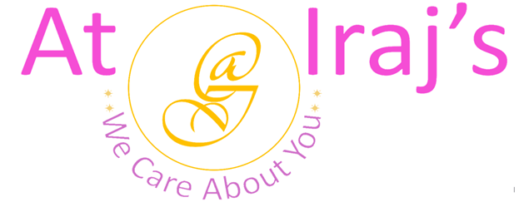
Herbal Brown Henna Powder
Ingredients: Lawsonia Inermis, Indigofera Tinctoria, Phyllanthus Emblica, Terminalia Chebula, Terminalia Bellirica, Eclipta Alba, and Bacopa Monnieri.

Scientific Name | Common Name
Lawsonia Inermis | Henna
Indigofera Tinctoria | Indigo
Phyllanthus Emblica | Amla
Terminalia Chebula | Harad
Terminalia Bellirica | Behada
Eclipta Alba | Bhringraj
Bacopa Monnieri | Brahmi

Product Description: This package contains 100% organic Herbal Brown Henna powder.

Benefits:
Henna
- Nourishes and acts as a deep conditioner for your hair.
- It makes your hair stronger, thicker, and radiant.
- Improves follicle health and works as dandruff treatment.
- Prevents hair loss and corrects hair thinning.
- Repairs split hair and balances pH and oil production.
- When used as dye, henna gives rich shade with each application.
- Treats dry, damaged, and unhealthy hair.
- The antifungal and antimicrobial properties in henna soothes your scalp and controls itching.
Indigo
- Nourishes and acts as a deep conditioner for your hair.
- It makes your hair stronger, thicker, and radiant.
- Improves follicle health and works as dandruff treatment.
- Prevents hair loss and corrects hair thinning.
- Repairs split hair and balances pH and oil production.
- When used as dye, henna gives rich shade with each application.
- Treats dry, damaged, and unhealthy hair.
- The antifungal and antimicrobial properties in henna soothes your scalp and controls itching.
Amla
- Rich source of Vitamin C, Tannins, Phosphorous, Iron, and Calcium.
- The Vitamin C in Amla helps in regenerating skin cell resulting in healthy scalp.
- Promotes healthy hair and boosts hair volume.
- Tannins in Amla, protects the hair from photodamage (reduced strength, rough surface texture, dryness, color loss, brittleness).
- Prevents premature gray hair.
- Effectively removes chemical build-up from hair follicles .
- Good conditioner for hair.
- Restores pH levels of scalp.

Harad
- Rich source of Vitamin C, Iron, Manganese, Selenium, and Copper.
- It is commonly used in variety of Ayurvedic hair care treatment.
- The astringent property in Harad controls excess production of sebum.
- Due to its antibacterial and antimicrobial properties, it prevents the rapid growth of Malassezia yeast on scalp.
- Prevents split ends, hair loss, build up, and clogging of hair follicles.
- It helps the roots to absorb nutrients deeply promoting healthy and strong hair.
- Prevents scalp acne by removing the dirt, extra build up and dead cells.
- Repairs dry and dull hair.
Behada
- Rich source of Vitamin C, Iron, Manganese, Selenium, and Copper.
- It is commonly used in variety of Ayurvedic hair care treatment.
- The astringent property in Harad controls excess production of sebum.
- Due to its antibacterial and antimicrobial properties, it prevents the rapid growth of Malassezia yeast on scalp.
- Prevents split ends, hair loss, build up, and clogging of hair follicles.
- It helps the roots to absorb nutrients deeply promoting healthy and strong hair.
- Prevents scalp acne by removing the dirt, extra build up and dead cells.
- Repairs dry and dull hair.
Bhringraj
- Rich source of Vitamin C, Iron, Manganese, Selenium, and Copper.
- It is commonly used in variety of Ayurvedic hair care treatment.
- The astringent property in Harad controls excess production of sebum.
- Due to its antibacterial and antimicrobial properties, it prevents the rapid growth of Malassezia yeast on scalp.
- Prevents split ends, hair loss, build up, and clogging of hair follicles.
- It helps the roots to absorb nutrients deeply promoting healthy and strong hair.
- Prevents scalp acne by removing the dirt, extra build up and dead cells.
- Repairs dry and dull hair.

Brahmi
- Rich source of Vitamin C, Iron, Manganese, Selenium, and Copper.
- It is commonly used in variety of Ayurvedic hair care treatment.
- The astringent property in Harad controls excess production of sebum.
- Due to its antibacterial and antimicrobial properties, it prevents the rapid growth of Malassezia yeast on scalp.
- Prevents split ends, hair loss, build up, and clogging of hair follicles.
- It helps the roots to absorb nutrients deeply promoting healthy and strong hair.
- Prevents scalp acne by removing the dirt, extra build up and dead cells.
- Repairs dry and dull hair.

How to Use:
Approximate Quantity:
- For short hair (Shoulder length and above)- 75 to 100 grams
- Medium hair (mid-level back and above)- 150 to 200 grams
- Long hair (Waist and above)- 220 to 250 grams

- Application Instruction:
Step 1: Wash your hair.
Step 2: Make herbal brown henna paste with warm water right before application.
Step 3: Apply herbal brown henna paste to clean and dry hair.
Step 4: Cover your hair with shower cap and let it sit for an hour.
Step 5: Wash your hair using At Iraj’s herbal cleanser.
Note:
- At Iraj’s we use 100% natural products, the above-mentioned benefits are not totally guaranteed.
- The amount of herbal brown henna powder depends on length and thickness of hair, the quantities mentioned above are estimated.
- Individual results may vary depending on hair type, existing chemical build up on hair
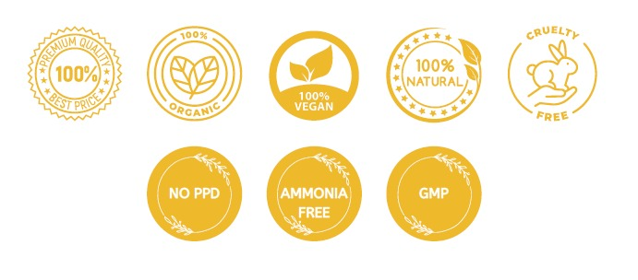For other products related info please visit us at: www.atirajs.com
If you need additional info or have questions related to any of our products, please email us at: support@atirajs.com
Always remember: We Care About You !!
Precaution:
This product (Herbal Brown Henna Powder) is for external use only. Keep out of reach of children and avoid contact with eyes. Before application do a small strand or patch test behind your ear and wait for 24 hours to make sure you are not allergic or sensitive to this product. If any itching, redness or burning occurs do not use this product and contact a doctor immediately. Not intended for eyebrows or eyelashes. If you are pregnant consult a doctor before application of this product.

Disclaimer:
The above statements have not been evaluated by the FDA. This product (Herbal Brown Henna Powder) is not intended to diagnose, treat, cure, or prevent any diseases.

