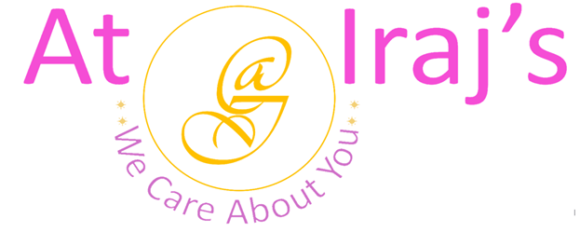
Wellness Skin and Hair Tea
Ingredients: Green Tea, Orange Peel, Rose Petals, and Kudzu Root.
Product Description: This package contains 100% organic wellness skin and hair tea.
Benefits:

Green Tea
- Rich in polyphenols which helps to reduce inflammation and fight cancer.
- Contains epigallocatechin-3-gallate (EGCG) also known as catechin which are natural antioxidants helps in preventing cell damage .
- Improves brain functioning.
- Lowers risk of cardiovascular diseases.
- Helps in weight loss, liver disorders, type 2 diabetes, and alzheimer’s.
Orange Peel
- Rich in vitamin-C.
- Limonene in orange peel lowers the risk of cancer .
- Improves digestion, immunity, heart, lung, and skin health.
- Pectin in orange peel helps lower the blood sugar levels.
- Helps in weight loss.
- Improves oral health.
Rose Petals
- Helps with dysmenorrhea and PMS symptoms.
- Reduces stress and anxiety.
- Decreases sebum production, treats scalp issues, and promotes overall healthy hair growth.
- Improves immunity.
- Helps sleep better.
- Lowers risk of chronic diseases.
- Soothes respiratory tract, lung, and throat infections.
Kudzu Root
- Helps with metabolic syndrome symptoms like high blood pressure and cholesterol.
- Reduces alcohol dependency.
- Protects cell damage from oxidative stress.
- Promotes heart health.
- Boosts antioxidant levels and reduces inflammation.
- Improves vasomotor symptoms like night sweats and hot flashes caused by menopause.

- Tea Making Instructions:
Step 1: Boil 7 to 8 oz of water.
Step 2: Add one teaspoon or 3 grams of tea.
Step 3: Steep for 3 minutes.
Step 4: Strain your tea in a cup.
Step 5: Enjoy your wellness skin and hair herbal tea.
Note:
- At Iraj’s we use 100% natural products, the above-mentioned benefits are not totally guaranteed.

For other products related info please visit us at: www.atirajs.com
If you need additional info or have questions related to any of our products, please email us at: support@atirajs.com
Always remember: We Care About You !!
Precaution:
This product (Wellness Skin and Hair Tea) is for external use only. Keep out of reach of children. If you are pregnant, nursing or have any medical condition please consult a doctor before use of this product. If you are allergic to any of the ingredients do not consume. If nausea, vomiting, or diarrhea occurs do not use this product and contact a doctor immediately.
Disclaimer:
The above statements have not been evaluated by the FDA. This product (Wellness Skin and Hair Tea) is not intended to diagnose, treat, cure, or prevent any diseases.

