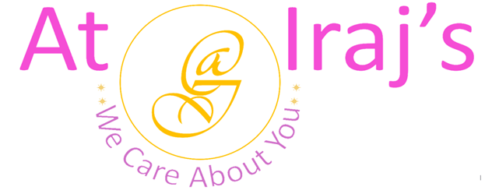
Anti-Ageing Face Pack
Ingredients: Bentonite Clay also known as Fuller’s Earth, Curcuma Longa, Hibiscus Rosa- Sinensis, and Rosa.

Scientific Name | Common Name
Bentonite Clay | Multani Mitti
Curcuma Longa | Turmeric
Hibiscus Rosa- Sinensis | Hibiscus
Rosa | Rose Petal

Product Description: This package contains 100% organic Anti-Ageing Face Pack powder.

Benefits:
Multani Mitti
- Cleanses skin deeply by removing dirt and impurities.
- Removes and controls excess oil and sebum.
- Reduces blackheads/whiteheads, acne scars, and blemishes.
- Evens out and brightens skin tone.
- Shrinks the appearance of pores.
- Exfoliates your skin.
Turmeric
- Rich in antioxidants and anti-inflammatory properties which helps psoriasis.
- Adds natural glow to skin.
- Heals acne and lightens hyperpigmentation.
- Reduces dark circles.
- Prevents premature aging and wrinkles.
- Helps in healing wounds, cuts, and scars.

Hibiscus
- Rich source of AHA, antioxidants, BHA, calcium, copper, iron, magnesium, malic acid, niacin, protein, riboflavin, thiamin, vitamins A,B6, C,E, and K.
- Improves and evens skin tone.
- Fights acne and reduces pigmentation.
- Cleans and tightens skin pores and removes excess oil.
- Nourishes, Exfoliates, and moisturizers your skin.
- Improves cell turnover.
- Control melanin production.

Rose Petal:
- Fights acne and reduces pigmentation.
- Cleans skin pores and removes excess oil.
- Nourishes, Exfoliates, and moisturizers your skin.
- Balances skin’s pH levels.
- Natural skin toner and hydrator.

How to Use:

- Application Instruction:
Step 1: Take 1 tablespoon each of anti-ageing face pack, honey and 1 teaspoon of yogurt and make a thick paste by using rose water
Step 2: Apply it to your face and neck and leave it on for 30 minutes.
Step 3: Wash your face with cool water and pat dry.
Step 4: Apply hydrator or moisturizer.
Note:
- At Iraj’s we use 100% natural products, the above-mentioned benefits are not totally guaranteed.
- Individual results may vary depending on skin type.

For other products related info please visit us at: www.atirajs.com
If you need additional info or have questions related to any of our products, please email us at: support@atirajs.com
Always remember: We Care About You !!
Precaution:
This product (Anti-Ageing Face Pack Powder) is for external use only. Keep out of reach of children and avoid contact with eyes. Before application do a small strand or patch test behind your ear and wait for 24 hours to make sure you are not allergic or sensitive to this product. If any itching, redness or burning occurs do not use this product and contact a doctor immediately. Not intended for eyebrows or eyelashes. If you are pregnant consult a doctor before application of this product.
Disclaimer:
The above statements have not been evaluated by the FDA. This product (Anti-Ageing Face Pack Powder) is not intended to diagnose, treat, cure, or prevent any diseases.

