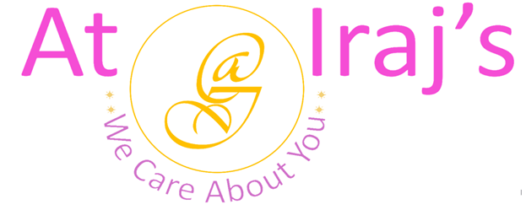
Wellness Metabolism Tea
Ingredients: Green Tea, Mint, Alma, Kudzu Root, and Shatavari.
Product Description: This package contains 100% organic wellness metabolism tea.
Benefits:

Green Tea
- Rich in polyphenols which helps to reduce inflammation and fight cancer.
- Contains epigallocatechin-3-gallate (EGCG) also known as catechin which are natural antioxidants helps in preventing cell damage .
- Improves brain functioning.
- Lowers risk of cardiovascular diseases.
- Helps in weight loss, liver disorders, type 2 diabetes, and alzheimer’s.
Mint
- Helps upset stomach (gas, bloating, nausea, and indigestion).
- Relieves headaches, migraines, and menstrual cramps .
- Kills dental plaque and freshens your breath.
- Mint has antibacterial, antiviral, and anti-inflammatory properties which helps in fighting sinuses infection, cold and flu symptoms.
- Reduces fatigue.
- Improves concentration.
Amla
- Excellent source of vitamin-C.
- Improves digestion and enhances food absorption.
- Boosts immunity and metabolism.
- Fights infection and chest congestion.
- Helps in weight loss.
- Improves digestions and helps with acidity and IBS problems.
- Promotes healthy skin.
- Treats chronic health conditions.
Kudzu Root
- Helps with metabolic syndrome symptoms like high blood pressure and cholesterol.
- Reduces alcohol dependency.
- Protects cell damage from oxidative stress.
- Promotes heart health.
- Boosts antioxidant levels and reduces inflammation.
- Improves vasomotor symptoms like night sweats and hot flashes caused by menopause.
Shatavari
- Improves female reproductive health, hormonal imbalances, and PCOS (polycystic ovary syndrome).
- Fights stress, anxiety, and depression.
- Boosts the production of milk in nursing women.
- Improves gastric ulcers.
- Lowers blood sugar levels.

- Tea Making Instructions:
Step 1: Boil 7 to 8 oz of water.
Step 2: Add one teaspoon or 3 grams of tea.
Step 3: Steep for 3 minutes.
Step 4: Strain your tea in a cup.
Step 5: Enjoy your wellness metabolism herbal tea.
.

Note:
- At Iraj’s we use 100% natural products, the above-mentioned benefits are not totally guaranteed.

For other products related info please visit us at: www.atirajs.com
If you need additional info or have questions related to any of our products, please email us at: support@atirajs.com
Always remember: We Care About You !!
Precaution:
This product (Wellness Metabolism Tea) is for external use only. Keep out of reach of children. If you are pregnant, nursing or have any medical condition please consult a doctor before use of this product. If you are allergic to any of the ingredients do not consume. If nausea, vomiting, or diarrhea occurs do not use this product and contact a doctor immediately.
Disclaimer:
The above statements have not been evaluated by the FDA. This product (Wellness Metabolism Tea) is not intended to diagnose, treat, cure, or prevent any diseases.

